**LAB 4: ADDING ROUTER AND ROUTES FOR END TO END CONNECTIVITY**

In last lab we manually added the flows in the switch using ovs-ofctl tool. In this lab assignment you will be writing a simple router with a static routing table. Your router will receive raw Ethernet frames. It will process the packets just like a real router, then forward them to the correct outgoing interface. We’ll make sure you receive the Ethernet frames; your job is to create the forwarding logic so packets go to the correct interface.

This assignment runs on top of Mininet. Mininet allows you to emulate a topology on a single machine. It provides the needed isolation between the emulated nodes so that your router node can process and forward real Ethernet frames between the hosts like a real router. Now, let’s begin with the lab.

**Case 1:**

In the first case, there are three different subnets in one openvswitch, i.e. 10.0.1.0/24, 10.0.2.0/24, and 10.0.3.0/24. If different hosts in different subnets want to talk to each other, we should add one router in this environment, i.e. r1. Note that many different IP addresses can be set to one interface in the router.

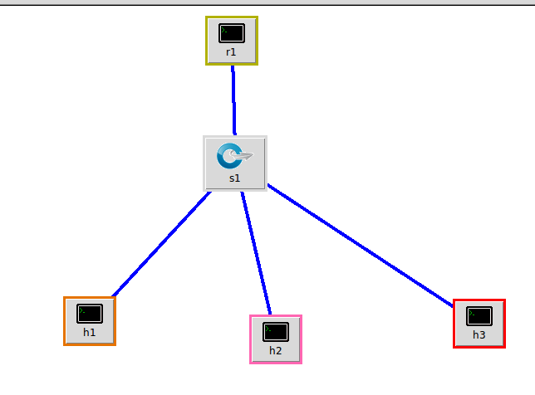

So, create topology give above using the lab code attached along with this file and deploy the topology in MiniNAM **(Please take a screen-shot of the topology)**

Try pinging between two host and check whether hosts are reachable or not.

**Note:** Please enter the MAC address and IP address in the code using following syntax:

**H<> = net.addHost( 'h<number>', ip="<IP_ADDR/MASK>", mac="<mac addr>" )**

Assign IP and MAC as follows:

H1 : ip="10.0.1.10/24", mac="00:00:00:00:00:01"

H2 : ip="10.0.2.10/24", mac="00:00:00:00:00:02"

H3 : ip="10.0.3.10/24", mac="00:00:00:00:00:03"

Note that IP of every host is in different subnet.

**Step 2:** Next thing you need to do it is to check the ip configurations of the hosts and the router. If there is any IP address assigned to the router, we need to remove it. For doing the same, open the xterm of the R1 and check the IP address. Then issue the following command:

**ifconfig r1-eth0 0**

This will delete your IP address assigned to the interface. You can check now whether IP address is assigned to the interface using <ifconfig>.

Now we will add the IP address to the interface using the following command:



Note that you can add multiple IP address to the one port.

After changing the IP address of the router, next thing and important thing is to enable IP forwarding in the router.



Using the above command, we just set the flag in IP forwarding file as ‘1’ so as to enable forwarding on the router.

Next thing is to add default routes in the hosts to each other in order to make end to end connectivity. Use the following syntax for that:

**ip route add default via <Gateway IP address>**

For example, route in host h1 will be:



Similarly add the default routes for host H2 and H3 as well.

Now final step will be to add the flow routes in switch S1 so that the hosts and router can communicate with each other. You can check port with <**links**> command in the mininet CLI.

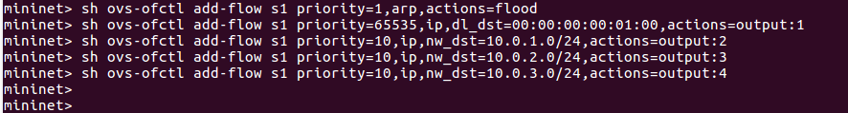

There should be 4 flows present in the switch.

1. Arp – This should be of least priority, we will need this if when MAC address is not known.
2. Destination MAC – This flow is implemented so that our switch would know where the packets should be sent when it receives from the hosts. For example, packet for the MAC address 00:00:00:00:01:00 will be forwarded through the ethernet port 1.
3. Next three flows will help the switch deliver packets to the respective host depending on the destination IP address in the packet. For example, hosts in 10.0.1.0 subnet will be forwarded through the ethernet port 2.

After implementing IP address, default route and the switch flows our case 1 is complete.

Now,

* Paste the screenshot of ping from h1 to h2 using **4 count ping command**.
* Paste the screenshot of traceroute from h1 to h3. (Traceroute in Mininet is Tracepath)
* Paste the screenshot of the routes in the router r1.

**Case 2:**

For case 2, create topology as give below. You can edit the topology you created previously.

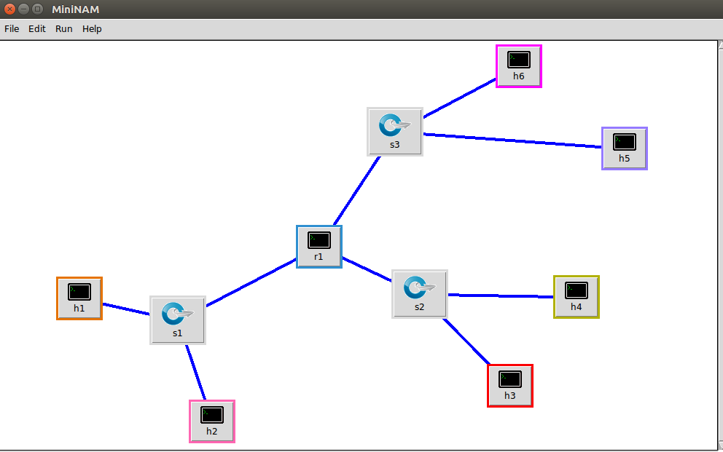

Give IP address and hosts for hosts as below:

h1: IP =10.0.1.10/24, mac=00:00:00:00:00:01

h2: IP =10.0.1.20/24, mac=00:00:00:00:00:02

h3: IP =10.0.2.10/24, mac=00:00:00:00:00:03

h4: IP =10.0.2.20/24, mac=00:00:00:00:00:04

h5: IP =10.0.3.10/24, mac=00:00:00:00:00:05

h6: IP =10.0.3.20/24, mac=00:00:00:00:00:06

Give the IP address and MAC address for the router at each interface. **Make sure you remove the any IP address assigned to any port before assigning the below IP addresses.**

Port0: IP =10.0.1.1/24, MAC=00:00:00:00:01:01

Port1: IP =10.0.2.1/24, MAC=00:00:00:00:01:02

Port2: IP =10.0.3.1/24, MAC=00:00:00:00:01:03

After assigning the IP address to router and hosts, enable the **IP forwarding** on the port. Once this is done, add the **default routes** in the hosts.

After this, we need to **add flows** in the all the switch. Every switch will have **four** flows like the ones I gave above. Please make sure you **check the ports** and assign proper output port and IP address.

After implementing IP address, default route and the switch flows our case 1 is complete.

Now,

* Paste the screenshot of ping from h1 to h4 using **4 count ping command**.
* Paste the screenshot of traceroute from h1 to h6. (Traceroute in Mininet is Tracepath)
* Paste the screenshot of the routes in the router r1.
* Paste the screenshot of flows in switch S2.

This concludes lab 4. Please submit your submission in ppt format.

Thank you.